FITTRACK
AI-Powered Fitness Tracking and Workout Recommendation API
Project Documentation

Prepared from the supplied screen-recording demonstration. The video shows a Node.js/Express backend being developed and tested through VS Code and an API client, with MongoDB connectivity and AI-assisted fitness recommendations.
Document purpose: to describe the project structure, API design, authentication flow, workout services, AI recommendation flow, request/response testing, and observed results.

Item | Details
Project name | FitTrack
Application type | REST API / backend service
Backend | Node.js + Express.js
Database | MongoDB (localhost connection shown)
AI component | Gemini-based workout recommendation service shown in the code
Testing tool | API client / Postman-style interface shown in the video
Development environment | Visual Studio Code

1. Abstract
FitTrack is presented in the video as a backend fitness application that combines user management, workout-related APIs, fitness insights, and AI-generated workout recommendations. The demonstration focuses on the server-side implementation rather than a complete mobile or web user interface.
The backend is organized using controllers, routes, middleware, models, and services. Authentication routes handle registration, login, and profile access. Workout routes support workout-related operations. An AI route connects application input such as age, fitness goal, and experience to an AI service and returns a personalized recommendation.
The video also demonstrates local execution of the server, MongoDB connectivity, API requests, validation, and successful JSON responses. The project therefore illustrates how a modern JavaScript backend can expose structured REST endpoints and integrate an AI service into an application workflow.

Key outcomes observed in the demonstration
- The backend server starts successfully in development mode on port 5000.
- The terminal shows a successful MongoDB connection to localhost.
- Authentication routes are defined for registration, login, and profile retrieval.
- The AI controller validates age, fitness goal, and experience before requesting a recommendation.
- The API client displays successful HTTP 200 responses for demonstrated AI-related requests.
- A fitness-insights request returns workout count, average duration, and total calories burned in JSON format.

2. Introduction
Fitness applications increasingly use software to record exercise activity, summarize progress, and provide personalized guidance. A backend API is responsible for storing user information, processing requests, enforcing access rules, and communicating with external services.
The supplied video demonstrates the implementation and testing of such a backend under the project name FitTrack. The code is organized as a Node.js application using Express.js. The application uses a modular structure so that authentication, workout processing, AI functionality, and supporting middleware can be maintained independently.
The most notable feature in the demonstration is AI-assisted workout recommendation. The API receives a small set of user characteristics and passes them to a Gemini-related service. The response is then returned to the API client as JSON, allowing a frontend application to display the recommendation.

Problem addressed
A general fitness application can store activity data, but users may still need assistance deciding what type of exercise plan is appropriate for their goals and experience level. The demonstrated AI endpoint addresses this by generating a recommendation from user-provided information.

Project perspective
This documentation describes what is visible in the video and uses standard backend concepts to explain the observed implementation. Where an internal implementation detail is not fully visible, it is described as an inferred design rather than as a confirmed feature.

3. Objectives and Scope

Objectives
- Build a modular REST API for a fitness-tracking application.
- Provide user authentication and profile-related operations.
- Support workout-related API routes and data handling.
- Generate AI-assisted workout recommendations from user inputs.
- Provide fitness insights such as workout count, average duration, and calories burned.
- Validate incoming request data and return structured error responses.
- Test the API endpoints using an API client before frontend integration.

Scope of the demonstrated system
- Backend development using JavaScript and Node.js.
- Express route/controller separation.
- MongoDB connectivity in a local development environment.
- Authentication middleware and protected routes.
- AI service integration for recommendations.
- REST API testing through JSON request bodies.
- JSON response generation for frontend consumption.

Out of scope in the supplied video
The screen recording does not provide enough evidence to document a complete production deployment, a complete frontend interface, mobile application screens, production database configuration, or detailed security hardening. These can be considered future development areas.

4. Technology Stack

Technology / Component | Role in the project | Evidence in video
Node.js | Runs the backend JavaScript application | Terminal shows node src/server.js
Express.js | Creates the HTTP server and routes | Route/controller files and express.Router() are visible
MongoDB | Stores application data | Terminal shows MongoDB connected to localhost
JavaScript | Primary backend programming language | Controller, route, service and server files are shown
Gemini AI service | Generates fitness/workout recommendations | geminiService.js and AI controller are shown
VS Code | Development environment | Project files and source code are visible
API client | Sends and inspects REST requests | GET/POST requests and JSON responses are shown
JSON | Request/response data format | Postman-style JSON bodies and responses are visible

Why these technologies fit the project

- Node.js enables JavaScript on the server and supports asynchronous API operations.
- Express.js provides a lightweight way to define REST endpoints and middleware.
- MongoDB is suitable for document-oriented application data and integrates naturally with JavaScript backends.
- A dedicated AI service layer keeps external AI communication separate from route logic.
- JSON makes the API easy to consume from web or mobile clients.

5. System Architecture
The video shows a layered backend architecture. A client sends an HTTP request to an Express route. The route forwards the request to a controller. The controller validates the input and calls the required service or data layer. The resulting information is returned as a JSON response.

Logical flow
- Client/API testing tool sends an HTTP request.
- Express receives the request through the appropriate route.
- Authentication middleware is applied where protection is required.
- The controller reads request parameters or JSON body data.
- Input validation checks required fields.
- The controller calls a service or database operation.
- The AI service communicates with the configured AI provider when an AI recommendation is requested.
- The controller sends a structured JSON response to the client.

Architecture diagram
Client / API Tester → Express Router → Controller → Service / Model → MongoDB or AI Service → JSON Response
The separation of concerns shown by this structure makes individual modules easier to test and modify.
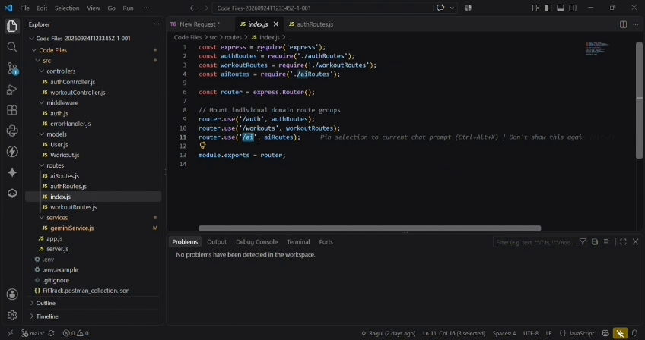
Figure 5.1 – Route index showing separate auth, workout and AI route groups.

6. Project Folder Structure
The VS Code Explorer in the video shows a modular project layout. The visible structure includes source folders for configuration, controllers, middleware, models, routes, and services.

Folder / File | Observed purpose
src/config | Application configuration area
src/controllers | Request-handling logic such as authController, workoutController and aiController
src/middleware | Authentication and error-handling middleware
src/models | Data models such as User and Workout
src/routes | API route definitions including authRoutes, workoutRoutes and aiRoutes
src/services | Reusable service logic; geminiService.js is visible
src/app.js | Application-level setup file visible in the project tree
src/server.js | Server entry point used to start the application
.env / .env.example | Environment configuration files visible in the project
FitTrack.postman_collection.json | API collection file visible in the project

Observed modularity
The structure avoids placing all application logic in a single file. Routes define endpoints, controllers process requests, middleware provides cross-cutting behavior, models represent stored data, and services handle reusable or external operations.
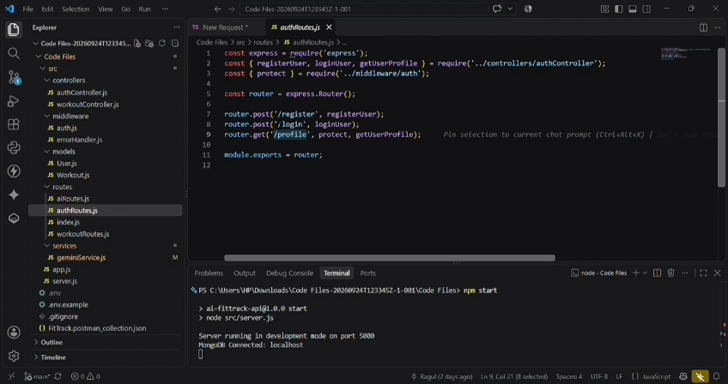
Figure 6.1 – Authentication route module in the VS Code project.

7. Server and Database Configuration
At the beginning of the demonstration, the application is started from the terminal using the npm start command. The terminal output shows the Node.js server running in development mode on port 5000. It also shows that MongoDB is connected to localhost.

Observed startup sequence
- Open the FitTrack backend project in VS Code.
- Run the project start command from the integrated terminal.
- The application launches the server through src/server.js.
- The terminal reports that the server is running in development mode on port 5000.
- The terminal reports a MongoDB connection to localhost.
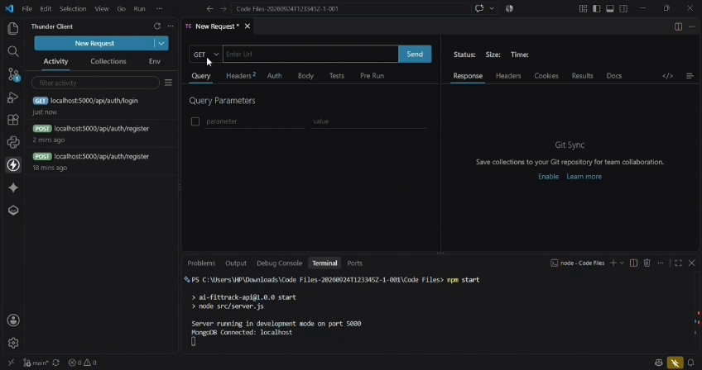
Figure 7.1 – Server startup and MongoDB localhost connection shown in the video.

Configuration principle
Environment-specific values such as database URLs, authentication secrets, and AI credentials should be stored in environment variables rather than hard-coded in source files. The video shows .env and .env.example files, indicating that environment configuration is part of the project structure.

8. Authentication Module
The authentication module shown in the video exposes registration, login, and profile operations. The route file imports controller functions and an authentication protection middleware.

Observed routes
Method | Route | Purpose
POST | /api/auth/register | Register a new user
POST | /api/auth/login | Authenticate an existing user
GET | /api/auth/profile | Retrieve the authenticated user's profile
The authentication route file visibly uses an auth middleware for the profile endpoint. This indicates that profile access is intended to be protected rather than publicly accessible.

Authentication flow
- User submits registration information.
- Server validates the request and creates the user record.
- For login, credentials are checked and an authentication response is returned.
- The client uses the authentication information for protected requests.
- The profile endpoint uses authentication middleware before the controller is executed.
Figure 8.1 – authRoutes.js showing register, login and protected profile routes.

9. Workout Module and Fitness Data
The project tree contains workoutController.js, workoutRoutes.js and Workout.js, showing that workout functionality is separated into controller, route and model components.

Likely data responsibilities visible from the project structure
- Workout model: represents stored workout information.
- Workout controller: processes workout-related API requests.
- Workout routes: exposes workout endpoints to clients.
- Fitness-insights endpoint: summarizes stored workout information.

Fitness-insights output demonstrated
Field | Example shown in video | Meaning
totalWorkouts | 3 | Number of workouts represented by the returned data
averageDuration | 1 hour | Average workout duration
totalCaloriesBurned | 100 | Total calories value returned by the endpoint
The exact database aggregation logic is not fully visible in the recording, so the table describes the response demonstrated rather than asserting the internal query implementation.
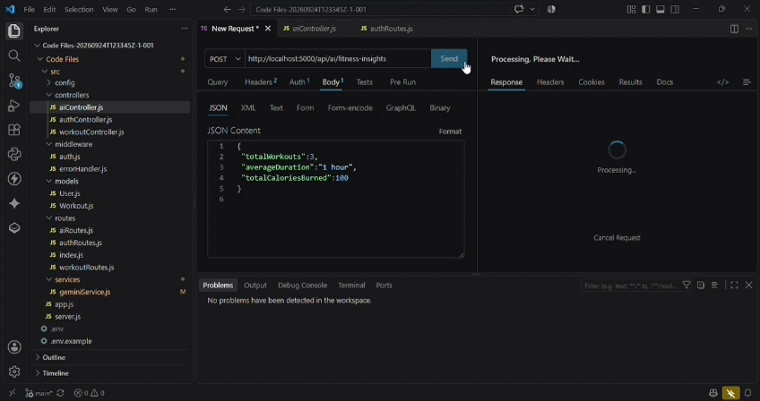
Figure 9.1 – Fitness-insights request body and JSON response shown in the API client.

10. AI Workout Recommendation Module
The AI functionality is implemented through a dedicated controller and service. The video shows aiController.js calling a geminiService.js module. This separation allows the controller to focus on HTTP handling while the service handles AI communication.

Observed endpoint
Method | Endpoint | Input fields shown
POST | /api/ai/workout-recommendation | age, fitnessGoal, experience

Validation shown in the controller
The controller extracts age, fitnessGoal, and experience from req.body. It then checks whether the required values are missing. If a required value is unavailable, the controller returns an HTTP 400 response with an error message requesting the required fields.

AI processing flow
- Receive JSON input from the API client.
- Extract age, fitness goal and experience.
- Validate the required inputs.
- Call the Gemini workout recommendation service.
- Receive generated recommendation text.
- Return the recommendation to the API client as JSON.
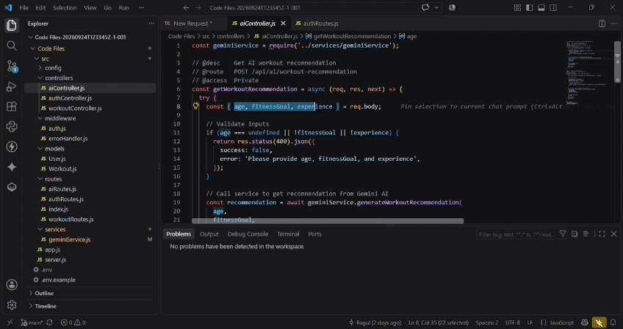
Figure 10.1 – aiController.js validating inputs and calling the Gemini service.

11. API Testing with the Client
The video uses an API testing interface integrated with the development workflow. Requests are sent to localhost:5000 and the returned HTTP status, response size, execution time, and JSON response are displayed.

Testing approach
- Select the HTTP method and local API URL.
- Choose the Body and JSON content option where required.
- Enter the request payload.
- Send the request.
- Check the HTTP status and response body.
- Compare the returned data with the expected API behavior.

Observed testing results
- Successful responses are displayed with HTTP 200 status for demonstrated requests.
- JSON responses are returned to the client.
- The API tester shows response timing and response size.
- The VS Code Problems panel shown in the video reports no detected workspace problems during the demonstrated stage.
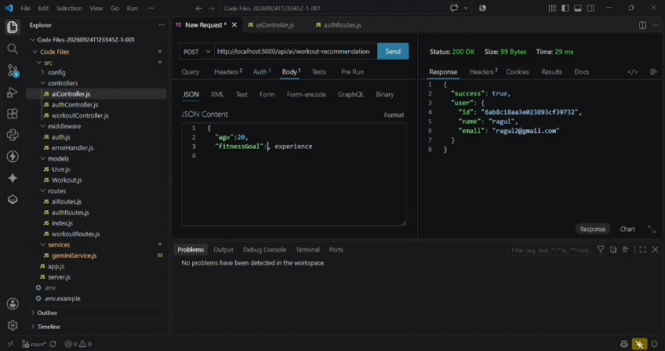
Figure 11.1 – API client displaying a successful JSON response for an AI-related request.

12. Sample Request and Response

Workout recommendation request
The video demonstrates a JSON body using the following fields. The values below reproduce the visible example structure without depending on any hidden implementation.
{
"age": 20,
"fitnessGoal": "fat loss",
"experience": "none"
}

Example response
{
"recommendation": "For your goal of fat loss, train three days per week with at least one rest day between sessions. Start each session with 5–10 minutes of easy movement, then do a squat, push, pull and hip-hinge exercise for 3 sets of 8–12 repetitions..."
}
The demonstrated response is natural-language guidance generated for the submitted fitness goal and experience level. The video also shows the API processing an AI request and returning the generated recommendation to the client.

API response characteristics
- Response is formatted as JSON.
- The recommendation is returned under a recommendation field.
- The client displays the generated text directly in the response area.
- HTTP 200 is shown for the successful demonstration.
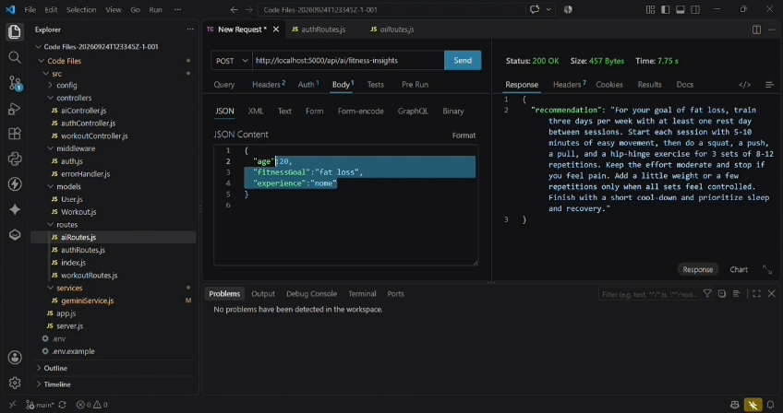
Figure 12.1 – Sample AI recommendation response returned by the API.

13. Testing, Results and Error Handling

Testing checklist
Test area | Expected behavior | Observed / documented result
Server startup | Application starts without startup failure | Server shown running on port 5000
Database | MongoDB connection established | MongoDB localhost connection shown
Authentication routes | Requests reach auth controller | Auth routes visible
AI input validation | Missing required values return client error | 400 validation response is coded
AI recommendation | Valid request returns recommendation | Successful response shown
Fitness insights | Summary fields returned as JSON | totalWorkouts, averageDuration and totalCaloriesBurned shown

Error handling approach
The AI controller shown in the video uses a try/catch structure and explicitly validates required input. A missing age, fitnessGoal, or experience value results in an HTTP 400 response. The project also contains errorHandler.js in the middleware folder, indicating a centralized error-handling component.

Result
The supplied recording demonstrates that the core backend workflow can be started locally, connect to MongoDB, receive API requests, validate data, call the AI service, and return JSON responses. These are the main functional outcomes evidenced by the recording.

14. Conclusion and Future Enhancements
The FitTrack demonstration presents a modular Node.js and Express backend for a fitness application. The project combines user authentication, workout-related data, fitness insights, and an AI-powered recommendation feature. MongoDB is used as the local database, while the AI functionality is separated into a service layer.
The video particularly demonstrates the complete request-to-response cycle for AI fitness recommendations: the API client supplies age, fitness goal, and experience; the controller validates the values; the Gemini service is invoked; and a recommendation is returned as JSON. The fitness-insights endpoint also demonstrates how stored fitness data can be summarized for a client application.

Future enhancements
- Build a responsive web or mobile frontend for the API.
- Add stronger authentication practices such as refresh tokens and secure password handling.
- Add comprehensive input validation and rate limiting.
- Store and display workout history with charts.
- Add role-based access control if multiple user roles are required.
- Add automated unit and integration tests.
- Improve AI prompt design and validate generated recommendations before displaying them.
- Add production deployment with secure environment variables and monitored database access.
- Add API documentation using OpenAPI/Swagger.

Final note
This 15-page document is based on the functionality and source-code/API-testing screens visible in the supplied video. It is intended as project documentation and can be further customized with the student's name, register number, institution, guide name, screenshots, and project-specific implementation details.
DEMO VIDEO : https://drive.google.com/file/d/1FktO6p-8JP3UgtR_GLGbXzIBhBu7qDEi/view?usp=sharing
API TESTING VIDEO : https://drive.google.com/file/d/17HyglXhBmg52VznseL_9H3qSjCP9GlSc/view?usp=sharing]
CODE: https://drive.google.com/drive/folders/1bDlH3ebfINtwfyARtMsZpcct-srZxEgx?usp=drive_link

